The application will:

* Ask the user if they want to use randomly generated fractions or enter up to two of their own
* Display a Fraction, ask the user to reduce the Fraction, then give an appropriate message of “Correct Reduction”, “Incorrect Reduction”, or “Incorrect Reduction, but Equivalent”.
* Display two fractions and ask what the result would be of adding, subtracting, multiplying, or dividing them.
* Ask the user to check how one fraction is relative to another. >, <, >=, <=, ==, !=.
* Ask the user to add one or subtract one to a fraction.

The application will have the following functions:

//*****************************************************

//Function Name: clear_screen

//Description: clears the console window, found it online because

// using system(“cls”) is a no-no

//Return Value: n/a

//Incoming Parameters: n/a

//Outgoing Parameters: n/a

<https://stackoverflow.com/questions/5866529/how-do-we-clear-the-console-in-assembly/5866648#5866648>

//*****************************************************

5 minutes

//*****************************************************

//Function Name: displayMenu

//Description: displays a menu for the user to make a selection

//Return Value: int

//Incoming Parameters: vector

//Outgoing Parameters: int

//*****************************************************

10 minutes

//*****************************************************

//Function Name: menuSelectionChecker

//Description: checks for valid selection

//Return Value: n/a

//Incoming Parameters: vector, int

//Outgoing Parameters: n/a

//*****************************************************

5 minutes

//*****************************************************

//Function Name: generateRandomFraction

//Description: returns a randomly generated fraction

//Return Value: Fraction

//Incoming Parameters: n/a

//Outgoing Parameters: Fraction

//*****************************************************

5 minutes

//*****************************************************

//Function Name: getUserFractions

//Description: asks the user for fractions

//Return Value: n/a

//Incoming Parameters: Fraction&

//Outgoing Parameters: Fraction

//*****************************************************

5 minutes

//*****************************************************

//Function Name: doMath

//Description: asks the user what type of math they want to do

// and asks them to do it

//Return Value: Fraction

//Incoming Parameters: Fraction

//Outgoing Parameters: Fraction

//*****************************************************

30 minutes

//*****************************************************

//Function Name: compareFractions

//Description: asks the user to determine if a fraction is

// >, <, >=, <=, ==, or != another fraction.

//Return Value: n/a

//Incoming Parameters: Fraction

//Outgoing Parameters: n/a

//*****************************************************

30 minutes

//*****************************************************

//Function Name: reductionPractice

//Description: asks the user for the reduced form, if one exists of

// fraction(s)

//Return Value: n/a

//Incoming Parameters: Fraction

//Outgoing Parameters: n/a

//*****************************************************

20 minutes

The menu will consist of a question and number options for the user to choose from where they enter 1, 2, etc. to make a selection.

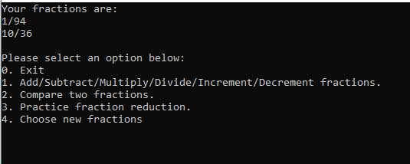

|  |  |  |  |
| --- | --- | --- | --- |
| Test Case: | Result Expected: | Result Received: | Date/Time Tested: |
| 3/4 + 4/3 | 25/12 | 25/12 | 2021-10-04 8:30 p.m. |
| 5/8 > 17/4 | False |  |  |
| 12/7++ | 19/7 |  |  |